| **Test Name** | | Add Worker to System | | | |
| --- | --- | --- | --- | --- | --- |
| **Use Case Tested:** | | Use Case 9 - Add Worker to System – Worker Id exists | | | |
| **Test Description:** | | User needs to add a new worker  User navigates to Manage Workers tab.  User is presented with a blank form to add the new worker details.  User enters the required information  User submits form  User amends input  User submits form | | | |
| **Pre-conditions** | | 1. Worker Id exists in the system 2. New worker Id does not exist in system | | | |
| **Post-conditions** | | 1. The user is advised that the worker Id already exists and to check input. Database is not changed. 2. The new worker is added, and the database is updated with the new record | | | |
| **Notes:** | | **This test is designed to show that if the new worker ID entered already exists, the user receives a message to indicate that work ID exists and to check their input. No data is changed in the database for the existing worker. User then amends ID to a unique ID and new worker details are accepted with database being update with new record.** | | | |
| **Result (Pass/Fail/Warning/Incomplete)** | |  | | | |
|  | **TEST STEP** | | **EXPECTED TEST RESULTS** | P | F |
|  | User selects “Manage Workers” from the menu bar | | A blank Worker Details form appears | X |  |
|  | User enters the Worker’s Id (an Id that exists) | | Input does not show error | X |  |
|  | User enters the Worker’s First Name | | Input does not show error | X |  |
|  | User enters the Worker’s Surname | | Input does not show error | X |  |
|  | User enters the Worker’s Position | | Input does not show error | X |  |
|  | User selects whether the Worker is active or not | | Input is accepted | X |  |
|  | User selects Submit button | | Message appears indicating the worker id exists and to check input | X |  |
|  |  | | No change is made to the database for the existing worker | X |  |
|  | User changes Id to correct Id | | Input does not show error | X |  |

|  |  |  |  |  |  |
| --- | --- | --- | --- | --- | --- |
| **Test Data Table** | | | | | |
|  | **1** | **2** | **3** | **4** | **5** |
| Test – 1 | 1234 | Gordon | Marvel | Pharmacist | Yes |
| Test – 2 | 2134 | Gordon | Marvel | Pharmacist | Yes |
| Test – |  |  |  |  |  |

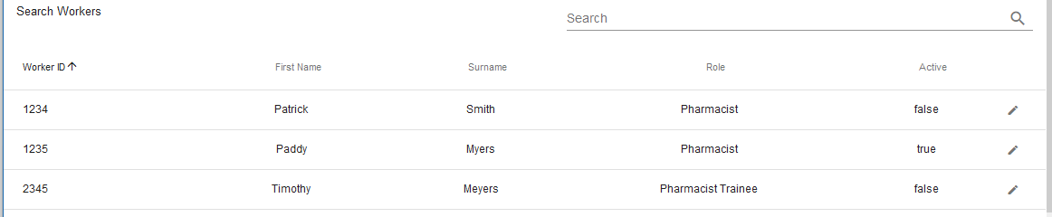

Existing worker Id 1234 details

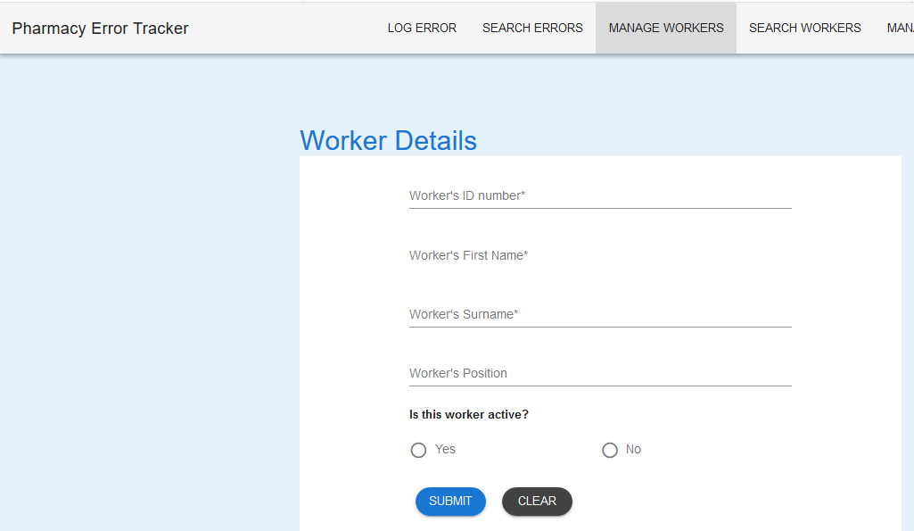

Worker Details Form

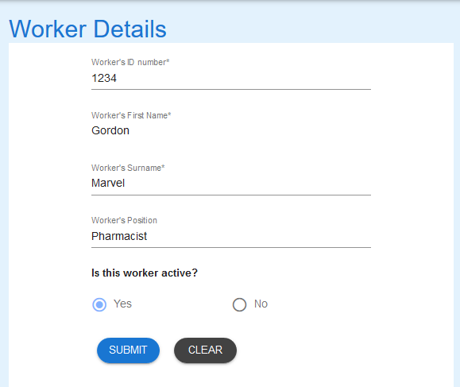

Worker details entered

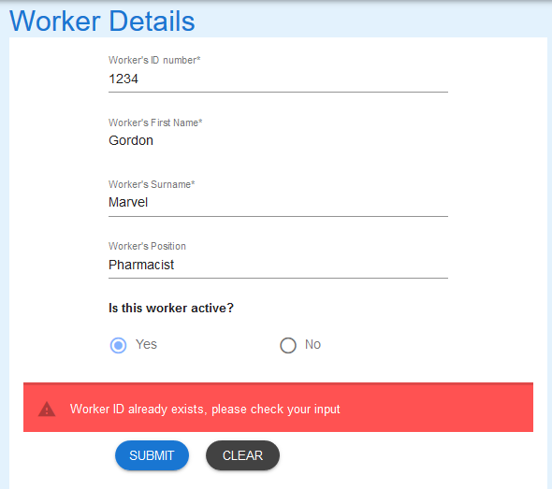

Message appears as expected

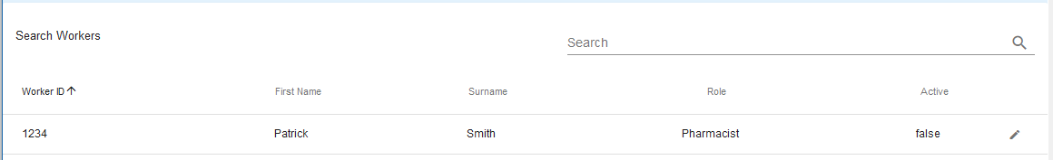

Details unchanged in database for worker Id 1234

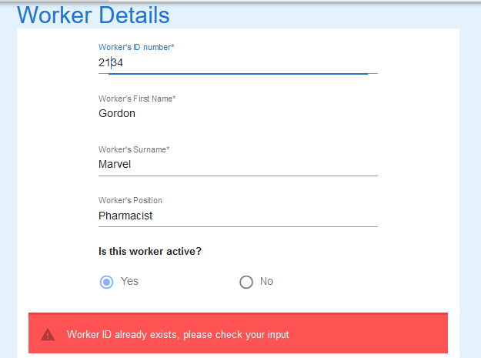

Worker Id amended to 2134

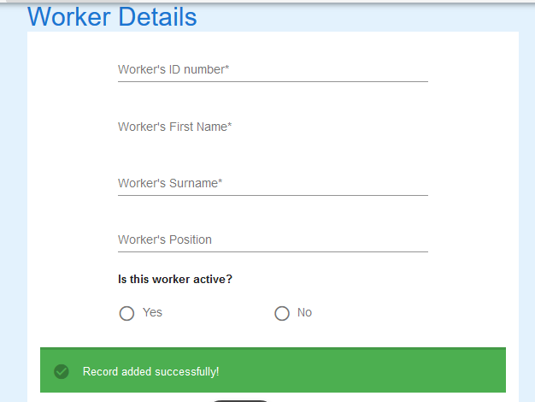

Message received to say record is added

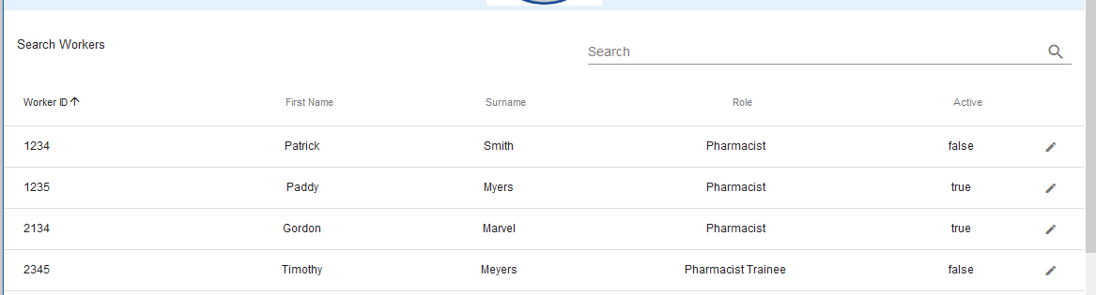

Database updated to include new worker Gordon Marvel.